November 17, 2008

Hi everyone!

Sorry about the “test” earlier! I think we have everyone’s halftime information up to date!

Speaking of halftime, it was great to see everyone- especially my gals from the 90’s! In case you missed it, I’ve attached a little blurb about us that ran in the Dallas Morning News. Enjoy!

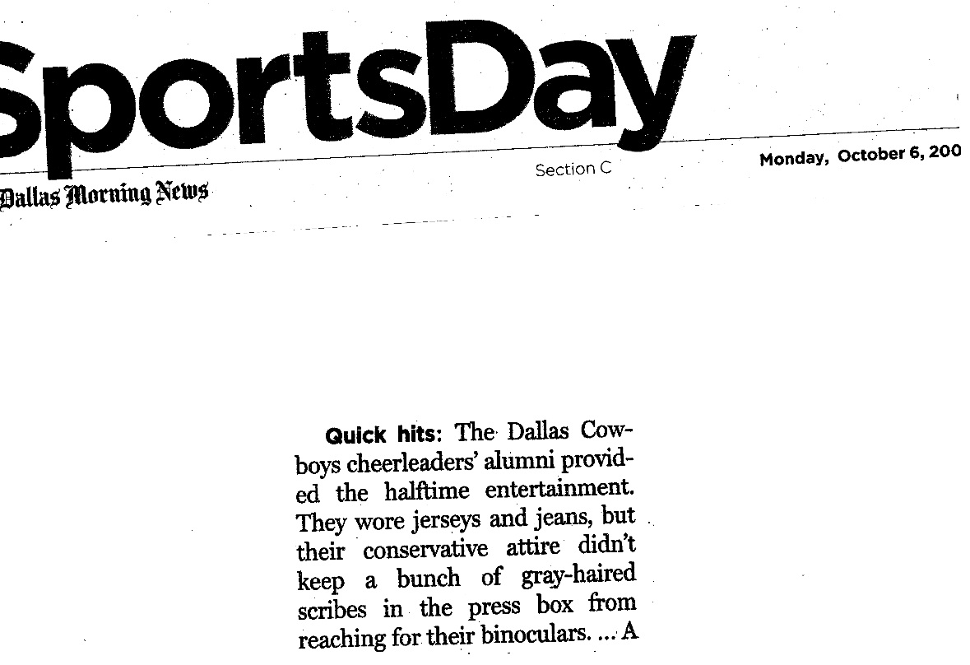
Check out the new DCC section on the Dallas Cowboys website! It’s great! You will also notice that our first “Where Are They Now?” story, Michelle Druga Fraser, is posted there as well. This be a weekly segment on the site so be sure and check your email- you may be next!

Feel free to contact me here with any updates or changes you may have- as always, PLEASE refer to your DCC name. With over 550 of us, that’s the easiest way to keep us all in line… Please be sure and update us when you move, etc. Most information from the office will be sent via email, so make sure we always have the most current email for you.

FYI- “Making the Team” is still airing on CMT- there’s only a couple left, but they air reruns all the time…

Superbowl 27 gals (or any Superbowl gals)- if you LOVED Gigi’s ring (like I did) let me know and I can put you in contact w/ Kelley Blunt Dixon…

Please continue sending in your pictures and stories! I’m always looking for new things for the site!

Cheers always,
Brooke Wicker Alexander
DCC 1992-1996

