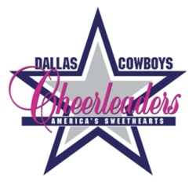

DCC ALUMNI UPDATE

September 2009

***THE NEW ERA BEGINS***

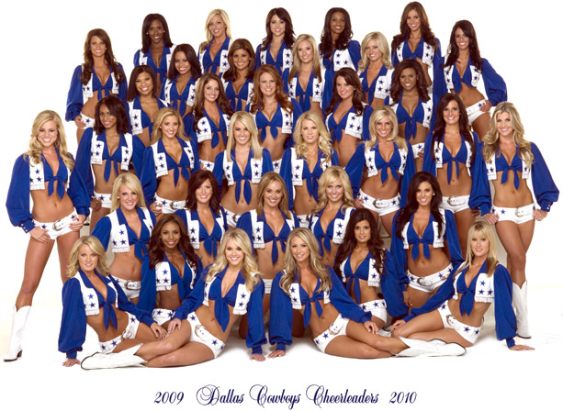
August 21, 2009- a day we will never forget. Sad in the sense that the final chapter of Texas Stadium has been closed and happy in the fact that our organization, with its deep sense of tradition and pride, will enter this new phase stronger and more popular than ever! We had 38 incredible years at Texas Stadium and are in for another 38 (at least) in our new home.

Thank you to those alumni who wrote letters to the girls before their first performance. I know it was last minute, but I so appreciate ya’ll rallying to the cause! There were two letters in particular that I wanted to share with all of you- they brought back fun memories and an incredible sense of pride. Enjoy!

As a rookie in 1995, I stood in the back row of Group 1 and sweat in places I didn’t know a woman could sweat and I absolutely hated my life. My boss couldn’t believe I needed to leave early AGAIN, I was put on the weight list the night before even though I was living off Power Bars, water and carrots, a six page report was due tomorrow on Gerald Keller (the god of managerial statistics), and I hadn’t kissed my husband – then boyfriend – since auditions in the Spring. My lifelong dream became a short lived goal – to simply make it through the first game, preferably ALIVE and hydrated.
There are certain necessary moments in a DCC’s season that completely sucks – and this is one of them. Rest assured it’s the fear of the unknown. As a rookie, I focused so much on a few 8 counts that were giving me trouble that I blanked out on other 8 counts. As a veteran standing on the outside, I was afraid the group would stop and I’d keep going. As a group leader, I fretted over hearing the wrong music, starting the wrong dance, taking the whole group with me and I’d lose them before the 2nd quarter. My feet hurt up into my shins and calves. My forearms ached from trying to be “punchy.” The skin on my face flaked from fake smiling. I looked all summer for a hairspray that would hold and not blind me when it got into my eyes. Kelli drew attention to how much she did NOT like my eye shadow, and Judy would pat me when she hugged me kind of saying in her gentle, non-verbal way, “Yes, for you, this will be a very l-o-n-g year.”
Here’s the deal: You’ll make it. See, girl, you HAVE to! You were chosen through a very elite selection process to stand in boots that ONLY you can fill. Forget the rookie and veteran crap – YOU were picked to do what the lady next to you can’t.
So, open your eyes wide, breathe in deeply, feel the air and listen purposefully to see, taste, feel and listen to YOUR individual experience. You’ll share this game and this year with millions, yet it will be uniquely your own if you’ll let it.
And, please know how much I appreciate your sweat, your boss, your education, your boyfriend or husband or mom or dad, your feet, smile, choice of hair spray and eye shadow AND for carrying the torch in a manner that alumni deem high class. In the cheerleading world, I promise, there is no higher status. Cheer on.

Cindi Burck Alsobrook (’95, ’96, ’97, ’99 & ’00)

Dear DCC 2009-2010,

You are about to embark on a journey that is like no other, become part of an elite club with fewer than 1000 members and delight millions. You are often imitated, but never equaled!

Performing at your first Dallas Cowboys Game is so exciting, so exhilarating, but for this year's squad it is also a new stadium and the organization's 50th anniversary. Perhaps the most exciting year yet.

Congratulations to each of you. You wouldn't be hearing this note unless you were the best of the best.

Have fun, inhale every moment, exhale every emotion. It will be over all too fast. What you do not yet realize is regardless of what else you do with your life being a Dallas Cowboys Cheerleader will forever define who you are.

We'll be watching you and cheering you on!
With love,
Dana Presley Killmer
DCC 1981-1985

In response to our letters, I received many thank you emails from the girls. This one letter captures it all:

My eyes swelled with tears reading letter after letter from so many of you wishing us luck, and giving us your words of wisdom for the special night of our first game at Cowboys Stadium.
Thank you so much for taking the time to send Kelli, Judy, and Rachel your e-mails, as they ensured we had the opportunity to read them before hitting the field. Since the game, Rachel has graciously packaged all of the e-mails into one bundle, so now we can remember your kind words forever and always!
Thank you for everything you did to set the standard of excellence, and thank you for sharing your legacy with us, and keeping us forever mindful of the precious gift we have in being one of America’s Sweethearts.
It is our wish and privilege to “continue the legacy of entertainment, beauty, character, talent, and class that has been set before [us] by so many.” -- Audrea Ulmer-Cowan (DCC ’03-’05)
Love & Cheers Always,
Ally Traylor (DCC 3rd yr. veteran)
In case you didn’t get tickets to “Opening Night”, check out the links below to see the girls pre-game performance. This footage is their favorite.

http://www.youtube.com/watch?v=qyVN6jpK5Jc

Part 1
http://www.youtube.com/watch?v=5Z3Zg2ERUiA
Part 2
http://www.youtube.com/watch?v=gV4N2eSKMWI

I asked three DCCs their thoughts on the first performance.. enquiring minds want to know!

Trisha Trevino- 5 yr. veteran
Did they use our standard intro? Often imitated....
We have a new announcer, but he introduced us with the same intro as we have always had. It starts with, "And now....Here they are.....America's Sweethearts, the Often Imitated, Never Equalled, Internationally Acclaimed, Dallas Cowboys Cheerleaders!" It makes us feel so proud to be a DCC.

Some of your thoughts about the day, game, etc.?
When we stepped onto the field to perform pre-game for the first time at the new Cowboys Stadium, I felt some of the same feelings that I felt when I was a rookie performing for the first time at Texas Stadium in Irving. I felt a wave of excitement, nervousness, and pride all at the same time. I could not believe we were actually the first Dallas Cowboys Cheerleaders squad to perform at Cowboys Stadium in Arlington. We made history the night of August 21st at our pre-season opener against the Tennessee Titans. Every move we made and every step we took that night will always be the "first" at Cowboys Stadium.

Before the game began, Kelli, Judy, Rachel, and Miko unveiled to us our brand new locker room, which I would describe as luxurious compared to our locker room at Tx Stadium in Irving. Every DCC has their own gigantic locker, consisting of 2 outlets each for us to plug in our curling irons, rollers, and straighteners. (We all shared about a total of 8 outlets at TX Stadium in Irving!) At the very back of each locker is a tall mirror. We can physically sit inside our locker and do our make-up in the mirror! There are also more cabinets and shelves than I could ever imagine a locker to have. It is unbelievable! Above all of our lockers, are our first and last names printed on a name plate. Just when we thought it could not get any better, we noticed our very own life-size pictures hanging above each one of our lockers. I could not believe my eyes! Wow!
Charlotte Jones Anderson (Executive Vice President Brand Management, President of Charities, President of DCC), came in to speak to us before we performed at pre-game. I will never forget the words she said, "We are all making history tonight." I remember thinking, "Wow, we really are making history tonight." It was such a special, historic night, and I felt so blessed to have had the honor to be apart of it. Throughout the game, I took in every single moment. I did not want to miss a thing! Everything about the new stadium was so perfect and "bigger than life." What makes it even better, is that we won!

This first game is a memory that I will cherish forever. Being a Dallas Cowboys Cheerleader, performing at the new Cowboys Stadium, and being apart of the Dallas Cowboys organization is such a blessing, and I will forever be thankful for this privilege.

Ally Traylor- 3rd yr. veteran

Our first game at the fabulous, new stadium was a BLAST! I sadly miss TX Stadium- I'm so glad I got to start my career as a DCC inside its humble walls!

Pam Seal (DCC ‘75) was practically on the field, hanging out of one of those VIP field suites! It was so nice to see a fellow DCC Alum! She was soooo proud, and just as energized as if she were back in her uniform!!!!!! Love her!!!!!

Did ya'll come out of a tunnel like the old stadium?
There are a total of five entrances or tunnels leading to the field. Unfortunately, we no longer have "The DCC Tunnel".
There are two, history-making, 50-yard line tunnels. These tunnels are really exciting, and the first of their kind in the NFL. One tunnel is located on the Cowboys’ side and the other on the Visitors’ side. The Miller Club, which is the actual name for the VIP tunnel, is really exciting because it gives fans the opportunity to reach out and touch their favorite player, or even say a few encouraging words as the team enters the field.
Finally, there are two more tunnels that look somewhat similar to the Cowboys’ and Visitors’ tunnels at Texas Stadium; however, they now belong to the DCC. Prior to the American Woman video, Often Imitated, and the pre-game show, 17 DCCs take to one tunnel and 18 to the other. We use these same two tunnels to come in for the half and to exit the field after we’ve WON the game!
What song did ya'll perform to (kickline and main routine)?
We danced to an energetic and catchy mix of “Boom Boom Pow” and “Showdown” by the Black Eyed Peas, and was about 4 ½ minutes long.
In past seasons, the “Dallas” exit always played immediately following the jumpsplit. Now, American Woman is replayed as we recover our poms and exit up the 50-yard line into the Miller Club aka Cowboys’ tunnel to prepare for Player Intro.
In the center of the walkway through the Club, is a beautiful and very large star that is brightly lit throughout the game. There’s no mistaking when the team is ready to hit the field and “bust” out of the tunnel. The entire Club fills with thick fog, blue lights turn on to emit just enough colored light to make the fog extra dramatic, and white lights illuminate our stars as we line the walkway of the Club in preparation for Player Intro.
Just before we lead the players onto the field, fans get to enjoy a dramatic and nostalgic series of video clips capturing some of the great plays and milestones in Cowboys history, and of course, video highlights of our starting line up. The music is perfectly timed with the video clips, and is truly exciting (I got major goose bumps). Just as fans are completely submerged into the video on the ULTRA SUPER MEGA JUMBOTRON, a live feed from inside the Cowboys tunnel takes over the screen, revealing America’s Sweethearts sparkling through the fog. Then suddenly, we BUST out of the tunnel, heading straight for another set of cameras that literally capture each DCC as we hit the green. WOW!
After Player Intro, and immediately following the National Anthem, the DCC take off towards each endzone, and onto the Touchdown Decks for our Kick-Off performance. Obviously, Touchdown Deck is a new term, and certainly a new (and exciting) concept for the DCC. The Touchdown Decks are located on top of the endzone suites that span the entire width of each end zone. The Touchdown Deck itself is about 5 yards wide, and is slightly tilted downward about 5 degrees. The squad dances half and half atop of the Decks, but remaining in their groups. For example, Group 1 and Group 2 will dance on the east Deck, and Groups 3 and 4 will dance on the west Deck. We dance in one straight line, and the Group Leaders thankfully are located in the middle of each Deck disseminating instructions down the line.
For the first game, we only danced on the Touchdown Decks for Kick-Off. It was so much fun, and the fans absolutely loved it, so thankfully Kelli and Judy had us dance on the Decks for Kick-Off AND the final two minutes of the fourth quarter for the second pre-season game!
After we exit the Touchdown Decks, we break into our individual groups and head for our corners. Not much has changed about dancing during the quarters, except we now have fans that literally sit in the most beautiful, luxurious chairs, bar stools and recliners you’ve ever seen. The patrons of these suits are all very nice, and energetic, but I found myself giggling a little bit because you can literally hear almost every conversation they’re having, especially when they’re talking about the Cheerleaders: Are we wearing hose or are we wearing tights? Wait, are they even wearing anything on their legs? How do they get those on? Are they attached to their shorts? The one comment I couldn’t stop giggling in my head about, and I think I will remember the man’s voice that said it for a long time to come was “Their shorts are so short, they could be belts.” How funny!
Aside from these funny comments, there were probably even more comments about our precision, poise and prestige. As I was taking a “quick” water break, I overheard a really refreshing conversation among a group of men sitting on the “patio” of their suite. The gentlemen were sitting around discussing how the Dallas Cowboys Cheerleaders started it all, and they have to work so hard to be apart of the team. One man even said something similar to “I bet they’re the hardest working team in the NFL,” and admitted to watching the reality show on CMT. Another man chimed in adding that obviously the girls are pretty, but they have to be intelligent, too. Not once did I hear a demeaning comment about our organization. Just before I stood up to rejoin my group, and of course while I was pretending to not be eavesdropping on their conversation, I heard a voice from directly over my shoulder say “Thank ya’ll for your hard work.” I turned over my shoulder, and standing next to me was an older gentlemen that just smiled saying “Ya’ll make us proud.”
Other thoughts?
The New, Fabulous, GINORMOUS, DCC Locker Room! I know what ya’ll are thinking. We’re spoiled! And, you’re right. We are!
I think the fabulous Ms. Toni Washington (DCC ’80-’83) put it correctly when she lovingly called us “The Million Dollar Babies.”
When we walked into the locker for the first time, Charlotte Jones Anderson was all smiles and eventually full of joyous tears as she graciously presented the locker room to Kelli, Judy and Dallas Cowboys Cheerleaders organization on behalf of the entire Jones family. Please know that each of you were in her heart when she presented the locker room. She recognized the legacy, honor and reputation that each of you built, and that she so wished she could have given you the locker room you deserved.

Mia Greenhouse- Rookie

Wow. The stadium lights, the thousands of screaming fans, the beautiful green Cowboys field, and just the stadium as a whole all contributed to the HUGE adrenaline rush I got as I "DCC walked" out of the tunnel for the first time. I had been hearing from alumni and veterans alike that stepping out of the tunnel for the first time would never be forgotten. I didn't understand at first, but now I realize what an amazing experience it really is. I was flooded with so many emotions! I was overwhelmed with joy, nervous, excited, and anxious all at the same time! When the Dallas Cowboys Cheerleaders intro began to play on the big screen, I went into a state of shock to see myself and my teammates 50 feet tall! I had to snap out of it as the tears welled up in my eyes because it was time to perform. It felt official that I was a DCC after we finished our pre game routine. After years of seeing the Dallas Cowboys Cheerleaders perform, I could hardly believe that I was actually on the field!! The entire game was a dream come true! It was so heartwarming to see how excited and anxious the fans are even to just get a glance at us strutting by! Dancing on the performance decks in the end zone was a new experience for all of us and was the most exciting part of the game for me. Our deck could see the other half of our team dancing on the opposite end zone and it looked so amazing!
In this new stadium the fun and excitement never stops. As soon as it's halftime, I am in awe at the beauty and size of the luxury that is our locker room. It is so nice for each of us to have our own locker, mirror, outlet plugs, and storage space. Some of the girls have actually fit inside one of the storage compartments in the locker! The walls are painted a beautiful pink and around the corner we are so thankful to have several stalls and showers! The countertops even have glitter in them! It is without a doubt the most beautiful cheerleader locker room in the NFL!
Every time we perform I get that same excited feeling I had at the first game. Even when I am allowed a water break I get a quick drink and jump right back into line because I don't want to miss a second of the action of the game! I can't wait for the opening regular season game against the Giants because I know it will be a whole different experience! I am so happy to share my thoughts with you and am so blessed to be a part of this amazing organization! I absolutely feel I am where I need to be and I won't take a single second for granted! I am so proud and blessed to be one of the thirty-five luckiest girls in the world!!

***ATTA GIRL!***
Way to go Jennifer Nix (DCC ‘06-’08) on your nomination as one of the “10 Most Beautiful Women in Dallas”! The alumni have voted and will be keeping our fingers crossed for the December 2009 release of D Magazine announcing your win! Jennifer wanted me to thank everyone for their votes!
Melissa Rycroft (DCC ‘06-’08) has been nominated for 2 Emmys! Yes, I mean those Emmys! She is up for “Best Breakthrough Performance” and “Best Female Performance” based on her appearances on “The Bachelorette” and “Dancing With the Stars”. The voting is online only- PLEASE vote for her at:
www.tv.com/breakthrough/
On September 14th, the Top 10 will be announced. There will be another vote and the Top 3 will be announced September 20th. Only the Top 5 are invited to attend the show. The Emmy award show is September 20th on CBS at 7:00. It’s up to us to get Melissa the recognition she deserves- vote, vote, vote!

***ENGAGEMENTS***
In addition to her Emmy nominations, Melissa has other exciting news to share! “The Bachelorette” is no longer! She got engaged to Tye Strickland on June 26, 2009. The engagement took place at White's Chapel Church in Southlake. It was private (just the two of them), and then he had their parents meet them at Brio restaurant in Southlake to celebrate. After that, they went to Cretia's where all their friends were to celebrate with them. They are keeping wedding details as quiet as possible....some information has been leaked, but they’re still trying to have a private day. We wish you the best and know that this one is forever and always!

***TELEVISION NEWS***
Season 4 of “Making the Squad” on CMT premieres October 10th. Tune in to see how the gals got ready for the new season in Cowboys Stadium.

***DCC COMPETITION***
The annual DCC Cheer Competition will be held on November 7th. Registration information can be found at Spiritcelebration.com.

***ALUMNI OUT AND ABOUT***
This edition of the “Alumni Update” is coming to you a little late because of my summer vacation. In the past 8 weeks I’ve moved back to Texas from Georgia (so glad to be home!), spent a month in San Francisco, and a week in Las Vegas. Mind you, I’ve literally driven across the country! Along the way, I checked in on several alumni- some of who I cheered with and some I met for the first time. It was so much fun swapping memories and catching up!

San Francisco Area Alumni
Leah Goodwin (DCC ‘97), me, Christina Carr (DCC ‘91-’95)

Las Vegas Area Alumni
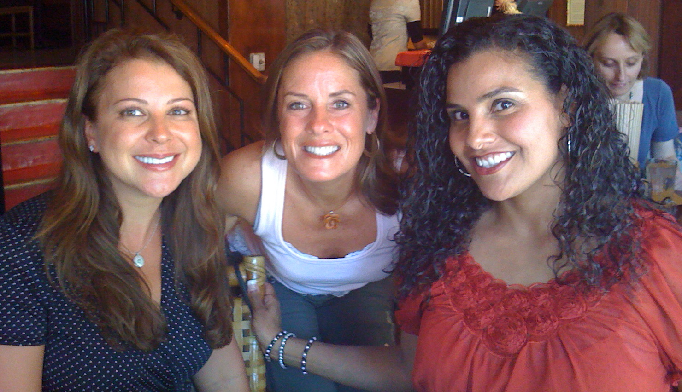
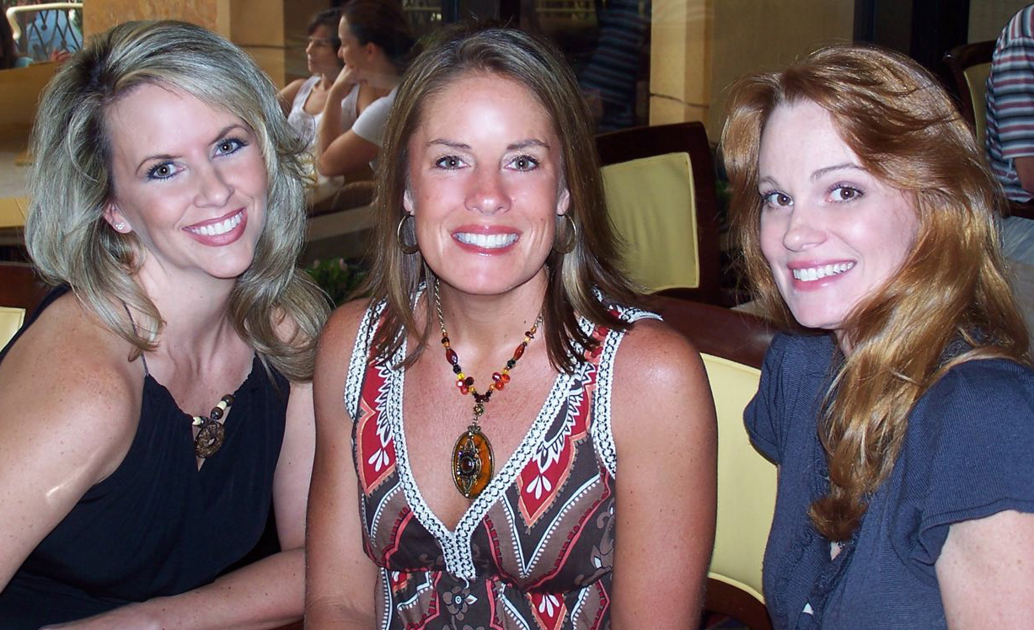
Kristen Pavuk Depew (DCC ‘90-’92), me, Barbara May Kraemer (DCC ‘85-’87)

In the October “Alumni Update”, I want to share what you did this summer! Please send me pics and stories from your summer vacation! I will print as many as space will allow.

***HAPPY BIRTHDAY!***
Please send me your birthday for a future section in the “Alumni Update”! If you’ve been profiled in “Where Are They Now?”, I’ve got you on the list! Thanks!

***PRAYER CIRCLE***
As most of you are aware, we lost a sister recently. Angela Morris Schaffer (DCC ‘86-’88) passed away August 5th. For those of us who didn’t cheer with her, I wanted to share her DCC cameo and a few words from fellow sister, Wendi White Wasson (DCC ‘80-’82), that she posted on Angela’s wall.
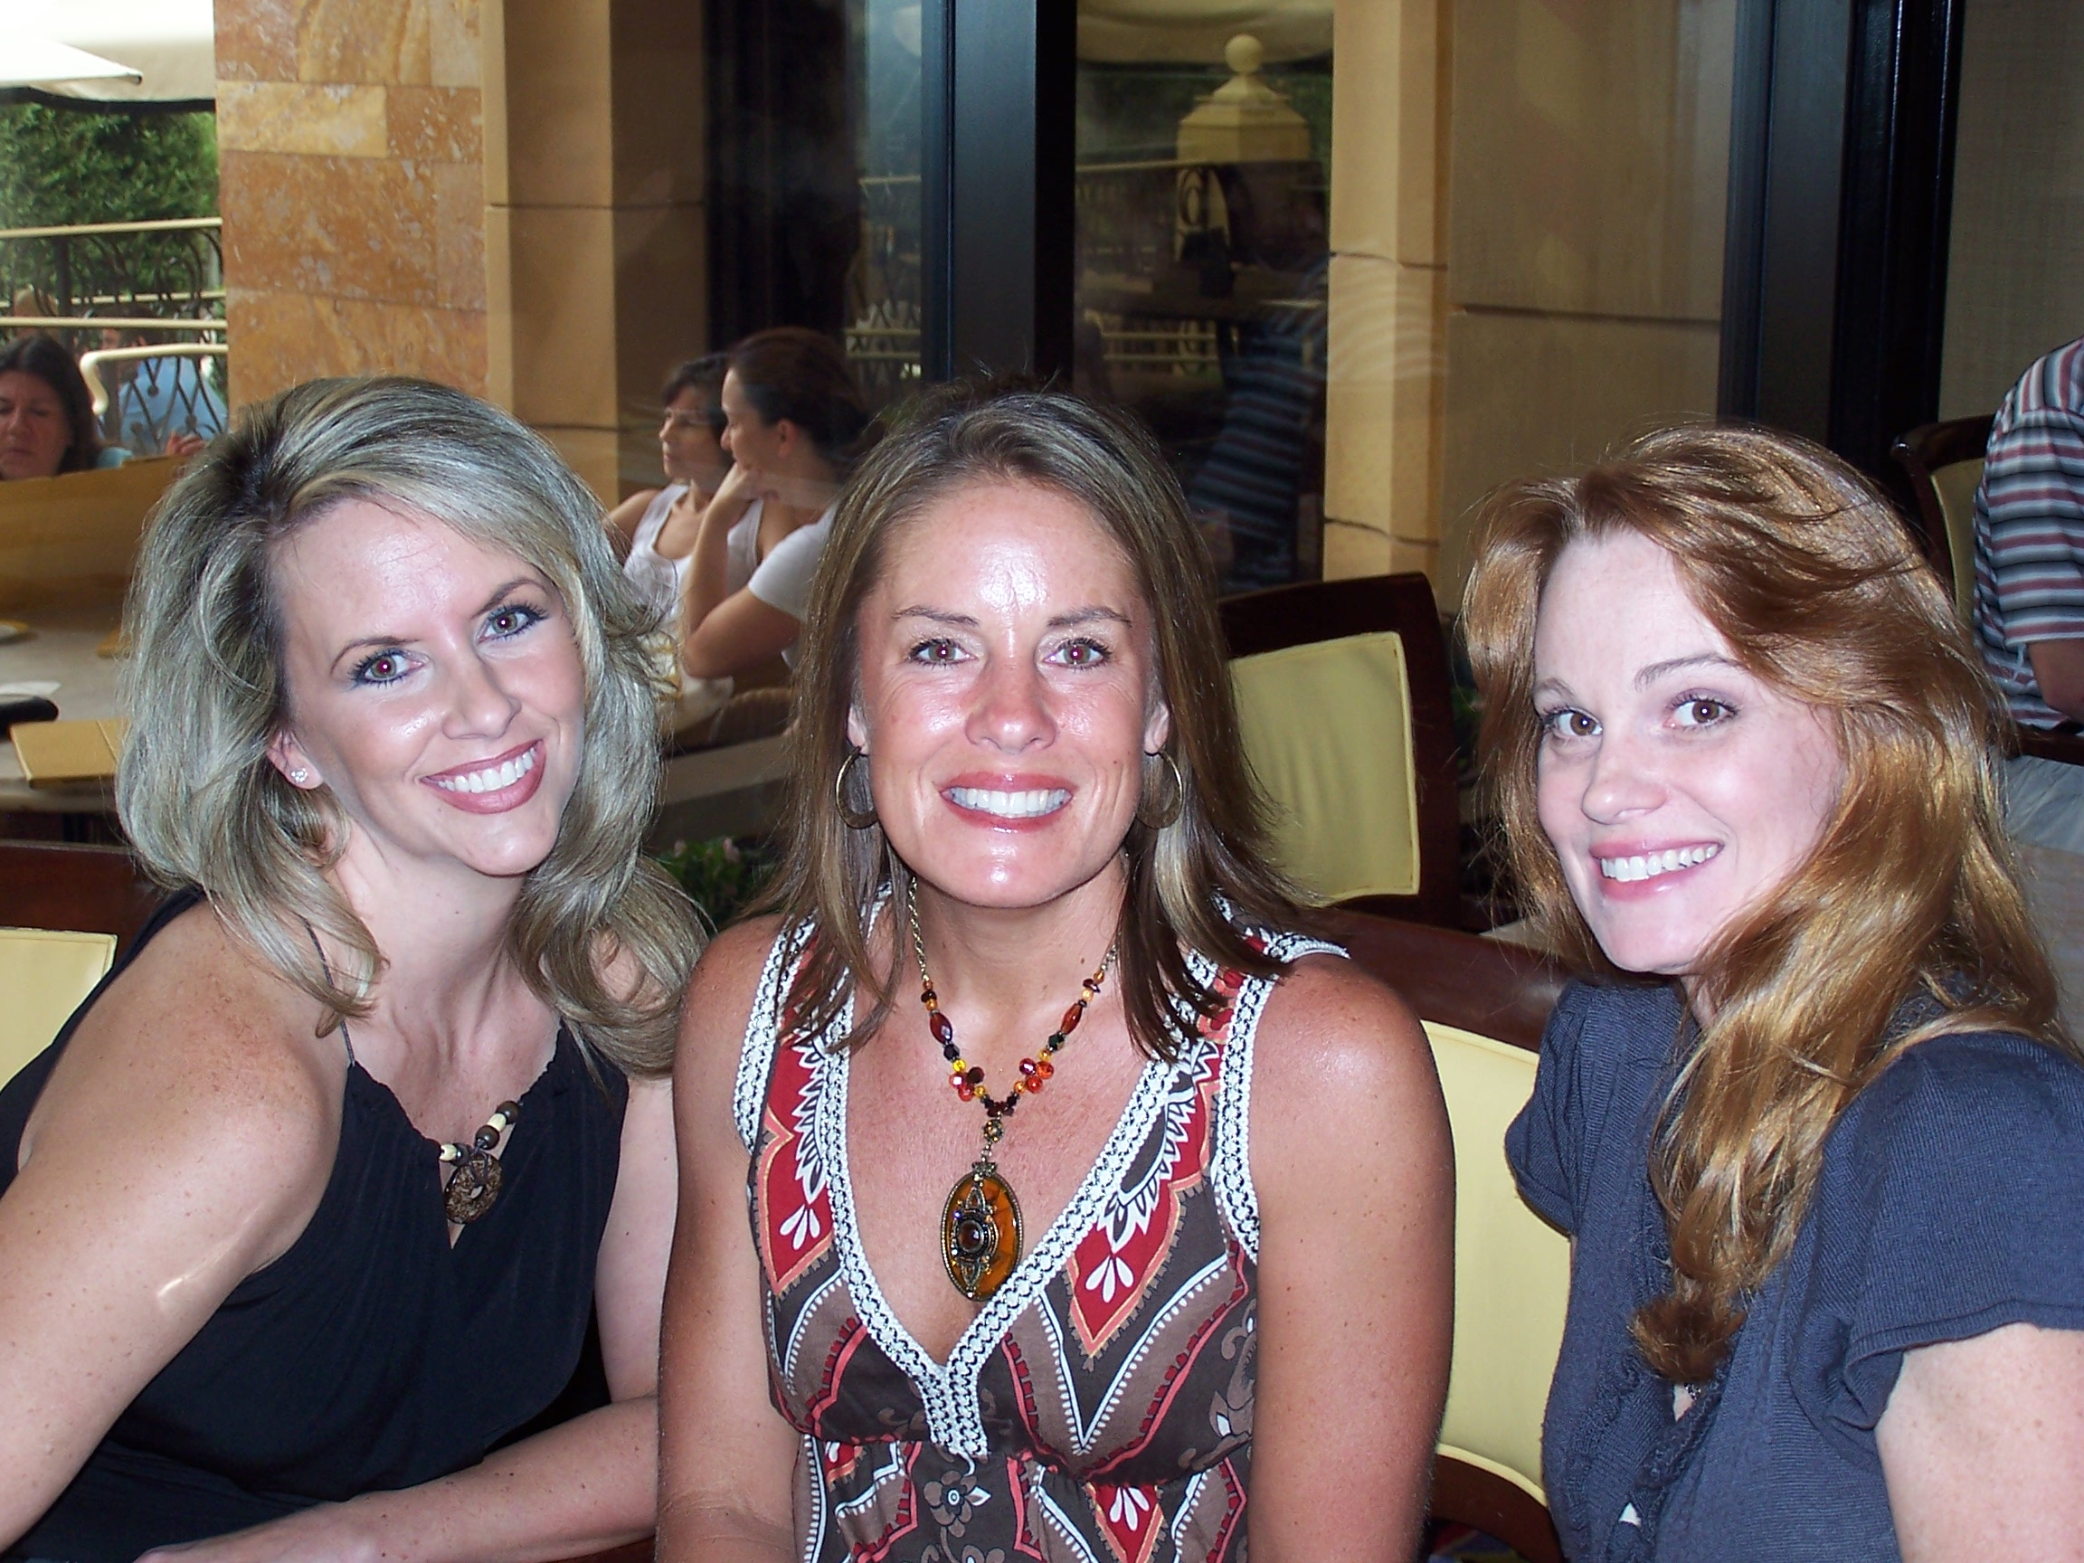
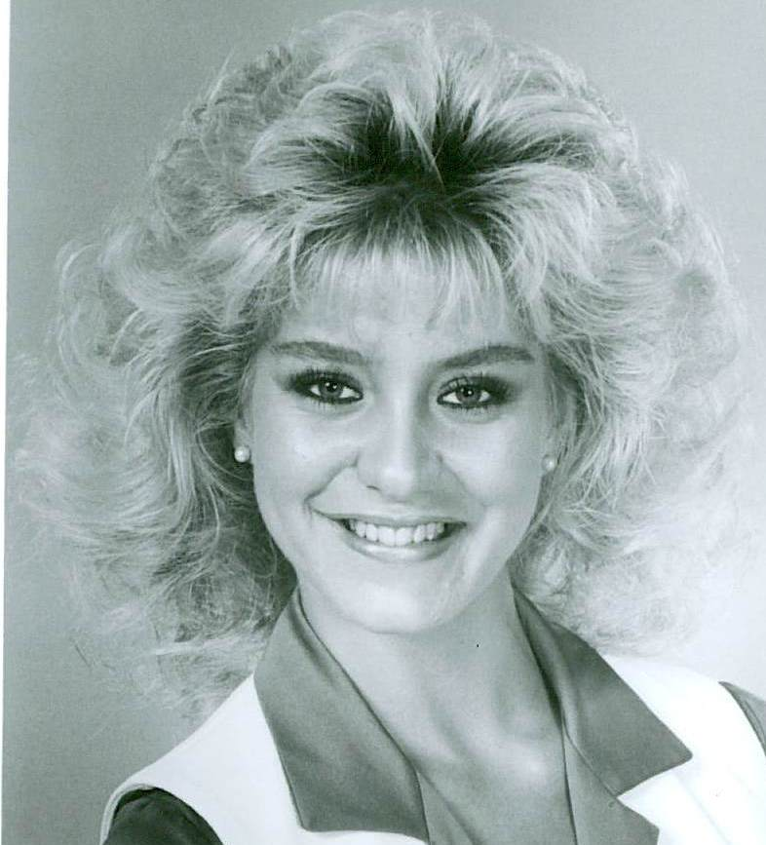
Although I didn’t know Angela, we share a deep hearted common thread of having been Dallas Cowboys Cheerleaders – a bond that only those of us who have been there understand fully. It is part of your soul, forever ingrained, through the experiences of the excitement, joy, fear, and challenges of representing the Dallas Cowboys, Texas, your family and mostly yourself, as a person who believes that excellence in all things is the standard, not the goal. From the previous comments, Angela had such qualities in all she did.
In Hawaii we have a saying that someone who passes has ‘changed address’, we just can’t see them. By talking about their life, love, and remembering their stories, they are not really gone.
Her spirit will always be on the sidelines with all of us, and she will be missed by her sisters of the Dallas Cowboys Cheerleaders. We too have lost a family member.
Wendi White Wasson DCC 1980-1981
***ALUMNI UPDATE***
As our “Alumni Update” progresses, please check your email capacity. The more pictures and info I put in, the larger my email is to you. I get an average of 12 emails kicked back to me due to size limitations. If you prefer me to send your update to a different address, please let me know ASAP.

Just a reminder.... PLEASE send me your summer vacation pics & stories, your birthdays, and other good news by SEPTEMBER 23rd for the October update.
What a month it has been! I hope your fall is off to a good start!

Cheers always,
Brooke Wicker Alexander- DCC 1992-1996

