

DCC ALUMNI UPDATE

July 2009

*** TRAINING CAMP ***

On Saturday, May 30th, 44 young ladies were selected to attend DCC Training Camp.

Introducing your 2009-2010 DCC Training Camp Candidates!

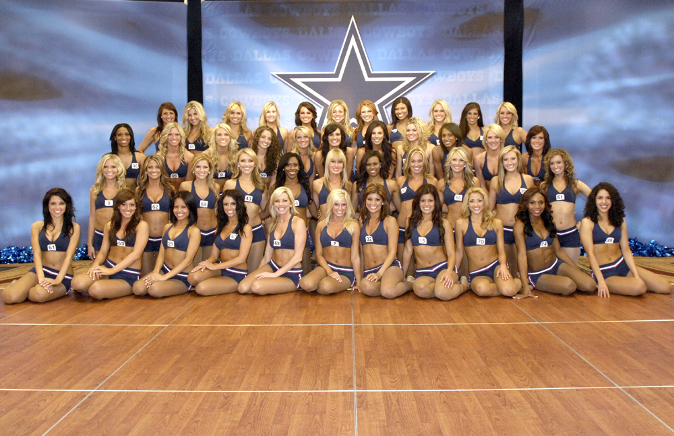

*** TRENDSETTERS ***

Once again, the DCC are the best in their field. Introducing the first ever, Dallas Cowboys Star Magazine Swimsuit edition! Our girls are featured in beautiful swimsuits and settings from their recent calendar shoot. The DCC are the first professional cheerleading organization to have such a magazine. Check your local pro shop for copies. If you have a subscription to Dallas Cowboys Star Magazine, you should have received a copy in the mail. Way to go girls!

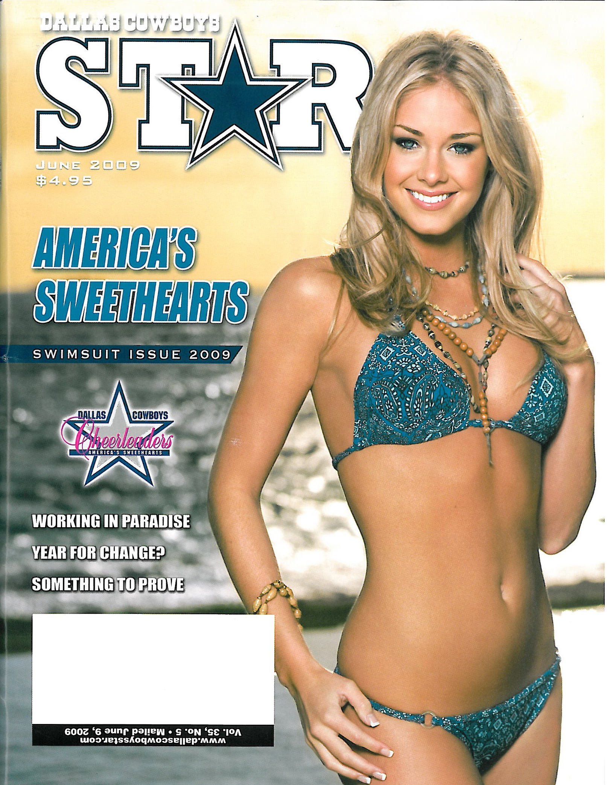
*** NEW ALUMNI ***

Welcome, welcome to our newest alumni sisters!

Makenzie Swicegood- DCC ‘05-09

Deryn Derbigny- DCC ‘06-09

Kandi Harris- DCC ‘06-09

Julie Jacobs- DCC ‘06-09

Dara McFarlane- DCC ‘07-09

Ryan Ray- DCC ‘07-09

Erica Jenkins- DCC ‘07-09

Sarah Clay- DCC ‘07-09

Stefani Peterson- DCC ’08

Lauren Castillo- DCC ’08

Jordyn Ketchum- DCC ‘08

*** REMINDER ***

As you’re cleaning out your closets this summer (it’s too hot outside to do much of anything else!), please let me know if you come across any DCC memorabilia you’d like to donate. We are building the archives and are always on the hunt for items from our past. A big thank you goes out to ChaChis Ortiz Hecht (DCC 1985) for giving us a wonderful banner from a DCC trip to Mexico. Thank you ChaChis!

We are building quite an archive of “Where Are They Now?” segments on the DCC website! Check out the most recent posts. I’m always looking for ladies to profile, so let me know if you’d like to participate!

*** CONGRATULATIONS ***

Heather Pliler (DCC ‘02-04) married Jeff Gorton on May 16th in Malibu, CA. Most alumni will agree that the lasting friendships are their fondest memory of being a DCC. Shown below are Heather, her fellow DCC sisters, and their treasured pinky rings!

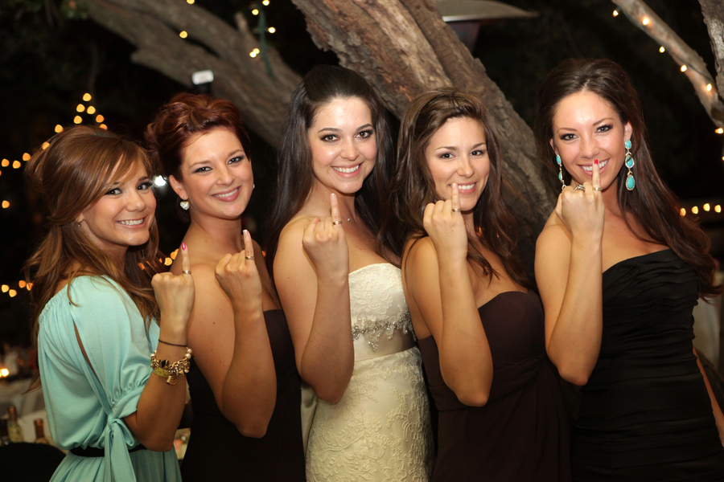

Left to right:
Liz Porter (DCC ’04), Amy Jo McKinley (DCC ’02), Heather, Monica Banfield Drew (DCC ’02), and Micaela Johnson (DCC ‘03-05)
Breah Brown Herzog (DCC ‘01-’03) competed in the Muscle Mania Lonestar Show in Houston, Tx on May 16th and won 1st place in the sport model division. The sport model division is for national fitness magazines to find their new faces for print work. Her first shoot is in the next couple of weeks and from there she competes in the National Europa Show on August 29th in Fort Worth. If any alumni should be back in uniform, it should be Breah! Rock on girl!
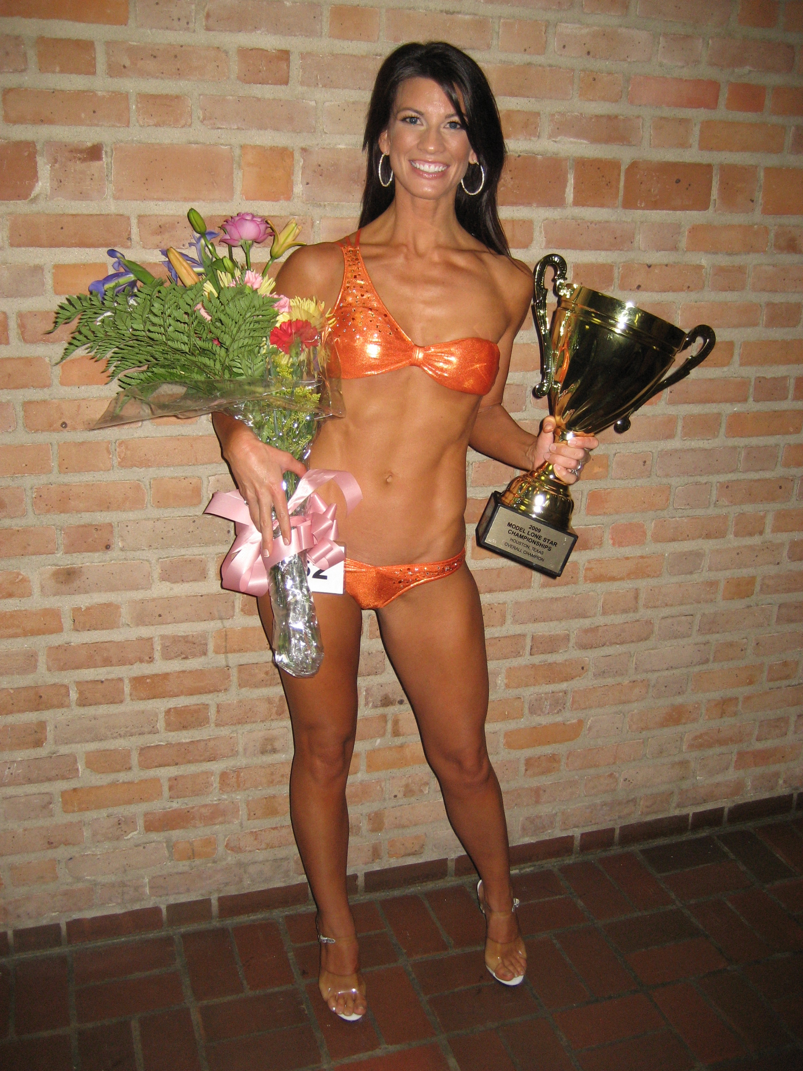

*** PRAYER CIRCLE ***
Our thoughts go out to Nancy Townes Turner (DCC ’80) on the passing of her son, Tye Parrish. He was only 26 yrs old when he lost his battle with cancer. There is a very nice medical care link http://www.caringbridge.org/visit/tyeparrish called caring bridge where Tye wrote his journals, and also where some of Tye's family photos are posted. Three medical charities close to Tye's heart are on his page, if any of you wish to donate. Nancy's email address is: patrickjfish@aol.com

A sisterly embrace goes out to Kelli McGonagill Finglass on the passing of her beloved dog, JoJo. JoJo was a Christmas gift to Kelli from the 1992 DCC squad.

*** MISSING ALUMNI ***
Attached please find the latest “missing alumni” list. We’ve made alot of progress in the last few months, but we’ve still got a ways to go. Thanks so much for your help on this!
Submissions for the August update are due JULY 15th. Can’t wait to hear what ya’ll are up to!
Happy 4th of July!
Cheers always,
Brooke Wicker Alexander- DCC 1992-1996

